FOR IMMEDIATE RELEASE
Media Contact:
Nicole Janok
Sharp Communications
(212) 829-0002 x122
nj@sharpthink.com

ART MIAMI SHOWCASES MAJOR WORKS THROUGH CURATED INDOOR/OUTDOOR SCUPLTURE EXHIBIT
Works to be Displayed Throughout the Art Miami Pavilion

MIAMI, FL – (November, 2011) Art Miami (www.art-miami.com), Miami’s longest running contemporary art fair and anchor fair to the City of Miami, will present a dynamic indoor/outdoor sculpture exhibit specially curated by Julia Draganovic. The fair will run from November 29 – December 4, 2011, in a state-of-the-art 125,000 square foot pavilion in Midtown, Miami’s burgeoning Wynwood Arts District. Art Miami has grown to include more than 110 galleries from 18 countries and will showcase 1,000 artists from 60 countries around the world. From the United States, 400 artists will be shown from nearly 100 cities. Art Miami annually features a compelling array of artwork from international galleries and prominent art institutions, including modern and contemporary paintings, drawings, sculpture, photography and prints from Europe, Asia, Latin America, India, the Middle East and the United States.

The curated indoor/outdoor sculpture exhibition will be presented throughout the Art Miami pavilion, featuring more than 20 stunning works from multiple artistic disciplines. Highlights of this year’s exhibition include three major modern works: Marc Chagal’s Les Amoureux à Saint Paul de Vence / La Fete Heureuse (1971-72) a mosaic the prolific artist created to celebrate his days in Saint Paul de Vence; French-born American artist Arman’s Wall of Violins (1984), a brilliant sculpture of violins made from die-cut brass; and famed Italian ceramic sculptor Carlo Zauli’s Stele (1972).
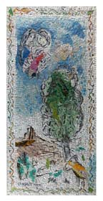

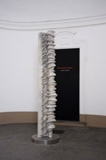
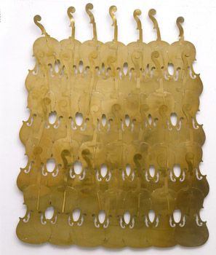

Marc Chagal’s Les Amoureux à
Saint Paul de Vence / La Fete Heureuse (1971-72)
Leslie Smith Gallery
Carlo Zauli’s Stele (1972)
Galleria Bianconi

Arman’s Wall of Violins (1984)
Allan Stone Gallery

A few site-specific pieces will be created for Art Miami’s façade and interior walls. After her memorable installation at the Bass Museum in 2004, Finnish artist Kaarina Kaikkonen, comes back to Miami to create one of her outdoor installations made out of local second-hand clothing specifically for Art Miami. The poetic palm tree installation titled "As A Tree, I Can Feel The Wind," picks up on global environmental issues in an encouraging way. Additionally, Sofia Maldonado, who is known for her urban sensibility that draws inspiration from aspects of street and youth culture, fashion and commercial design, abstraction and pop art, will produce, partly during Art Miami and in presence of the audience, two large-size wall panels featuring her ubiquitous brash girls.

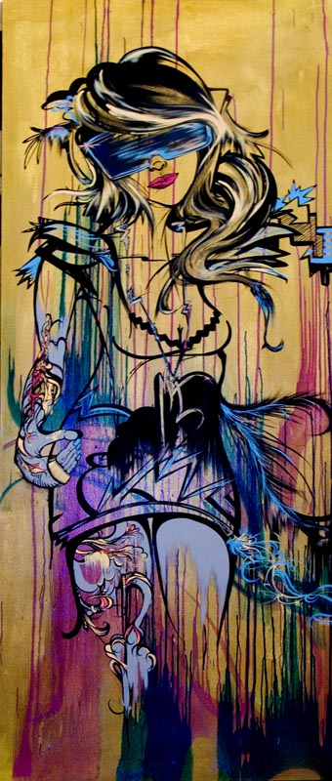
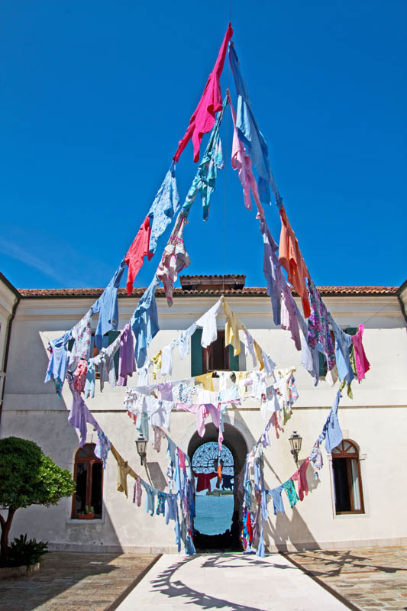

Kaarina Kaikkonen’s The Gate (2011) Galerie Forsblom
Sophia Maldonado’s Concrete Jungle Diva (2011) Magnan Metz Gallery

Other significant pieces in the exhibit include: Jim Dine’s Heart (1988); Federico Uribe’s Lady Bug (2011); Jonathan Prince’s never-before-seen Bore Block (2011); Greely Myats’ I Like The Way You Dance (2011); Daniel Borlandelli’s Williwaw (2011); Beto de Volder’s Dibujo Espacial (2007); Cheryl Pope’s Colts (2008); Simon Raab’s Petrified – Petrified over time or scared about tomorrow (2010); Peter Mill’s Weeping Woman (2007); Chul Hyun Ahn’s Visual Echo Experiment (2011); Carolina Sardi’s Bench (2011); Lino Tagliapietra’s Venice Panel; Carole Feuerman’s Monumental Brooke with Beach Ball (2010); Walter Robinson’s Fail Safe (2011); Tim Etchells’ neon works, Live Forever (2010) and Get Out (2010) and Scott Eunson will showcase a wall installation.

German-born Julia Draganovic is an independent curator and art critic with a particular interest in new artistic strategies and art in public spaces. She is curator of the International Award for Participatory Art, board member of institutions like No Longer Empty, New York, Mudam Luxemburg and the Outdoor Gallery of the City Gdansk, Poland. She also is curator of Bologna Art First, the series of installations in museums, public spaces and historical palazzos throughout the city of Bologna, initiated by Arte Fiera, Italy's oldest art fair.

The 22nd edition of Art Miami will officially kick off with its opening night on Tuesday, November 29, 2011. Art Miami’s highly anticipated Opening Night VIP Preview will benefit The Lotus House Women's Shelter, a quiet enclave in downtown Miami that offers a sanctuary for homeless women and infants in need. The exclusive evening is the first opportunity for VIP collectors to acquire some of the finest pieces of modern and contemporary art from the 20th and 21st centuries and attracts more than 7,200 museum curators, collectors, artists, connoisseurs, and interior designers the world over.

For more information visit: www.art-miami.com

Important Dates for Media:
Opening Night VIP Preview: November 29, 2011, 7 – 10 p.m.
Opening Day: November 30, 2011, 11 a.m. – 7 p.m.
Public Show Dates: November 30 – December 4, 2011
All press should register online prior to the fair at: art-miami.com/press.

For the latest updates on Art Miami and a full list of 2011 exhibitors visit art-miami.com
Find us on Facebook at facebook.com/art-miami or Twitter: twitter.com/art_miami

Press Contact:
For more information on Art Miami or for media credentials to attend, please contact Nicole Janok at 212-829-0002 Ext.122/ nj@sharpthink.com, Beryl Crofton-Atkins at bc@sharpthink.com /Ext. 113 or Stephanie Grabbe at sg@sharpthink.com /Ext. 103.

About Art Miami:
Miami’s longest running contemporary art fair, Art Miami will run from November 29 – December 4, 2011. As the anchor art fair to the City of Miami, the fair will return with a compelling array of modern and contemporary artwork from over 110 international galleries and prominent art institutions. Art Miami will be held in a state-of-the-art 125,000 square foot pavilion in Miami’s burgeoning Wynwood arts district. Art Miami’s highly anticipated Opening Night VIP Preview, on Tuesday, November 29, 2011, will benefit The Lotus House Women’s Shelter. $25 donation payable at the door or purchased in advance online at http://www.lotushouseshelter.org/events.html.

Art Miami Sponsors + Partners:
Art Miami is generously supported by: Mandarin Oriental, Miami; Persol eyewear; Sotheby’s International Realty; Balthazar magazine; Bootlegger 21 NY Vodka; Gander + White; Universal Travel; The Miami Herald; Spuntino Catering; Société Perrier; Heineken and Midtown Miami.

###

