ART MIAMI 2011: FACT SHEET

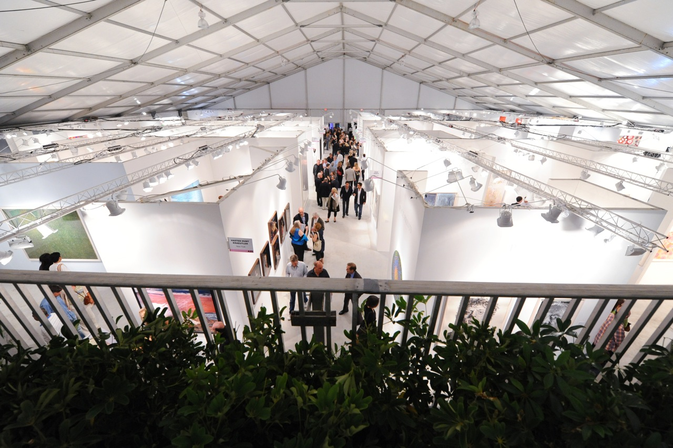

ART MIAMI 2011 VIP/PRESS PREVIEW & EVENTS

What:
Miami’s longest running contemporary art fair, Art Miami will run from November 29 – December 4, 2011. As the anchor art fair to the city of Miami, the fair will return with a compelling array of modern and contemporary artwork from over 110 international galleries and prominent art institutions. Art Miami will be held in a state-of-the-art 125,000 square foot pavilion in Midtown Miami’s burgeoning Wynwood Arts District. Art Miami has grown to include more than 110 galleries from 18 countries, and will showcase 1,000 artists from 60 countries around the world. From the United States, 400 artists will be shown from nearly 100 cities. Art Miami will feature a compelling array of artwork from international galleries and prominent art institutions, including modern and contemporary paintings, drawings, sculpture, photography and prints from Europe, Asia, Latin America, India, the Middle East and the United States.

Location:
The Art Miami Pavilion
Midtown Miami | Wynwood
3101 NE 1st Avenue (between NE 31 ST and NE 32 ST)
Miami, FL 33137

Fair Hours:
Wednesday, November 30 – Saturday, December 3, 11 am - 7pm
Sunday, December 4, 11 am - 6pm

Tuesday, November 29, 2011
Opening Night VIP Preview
5:30 PM –7:00 PM – Lotus House Benefit

The Sundari Foundation invites collectors and art lovers to experience a first view of the highly anticipated Art Miami Fair at a cocktail reception benefiting The Lotus House Women’s Shelter, a quiet enclave in downtown Miami offering a sanctuary where the minds, bodies and spirits of homeless women and infants most in need are supported, nurtured, uplifted and afforded an opportunity to learn and grow on every level. $25 donation payable at the door or purchased in advance online

7:00 PM – 10:00 PM – VIP Preview opens to all Art Miami VIP Cardholders and press. Cocktails and Hors d’oeuvres will be served.

Persol Art Video | New Media Lounge
Tuesday, November 29 – Sunday, December 4 during fair hours
"ZOOOM! Decoding Common Practice"

Curated by Julia Draganovic, the show “ZOOOM! Decoding Common Practice” will present six videos by artists, who research the human condition and experiment with the variety of tools that video art provides. It reveals a glimpse beyond the ordinary and discovers the precariousness of the stability that those communities try to maintain. “ZOOOM! Decoding Common Practice” is the fourth video program sponsored by Art Miami. It follows the fair’s well-received 2010 Art Video Lounge, also curated by Julia Draganovic.

The artists include:
- Ai Weiwei: Chang’an Boulevard. Courtesy of Collection Fondazione Cassa di Risparmio
Modena, Italy.
- María Teresa Hincapié: Una Cosa Es Una Cosa. Courtesy of Colección de Arte del
Banco de la Republica, Bogotà, Colombia.
- Lucia Nimcová: Double Coding. Courtesy of Mudam Musèe d'Art Moderne du Grand-Duc Jean, Luxemburg
- Miguel Angel Rios: Matambre. Courtesy of the collection Boris Hirmas Said, Miami.
- Isabel Rocamora: Body of War. Courtesy of the Collection Manuel de Santaren, Boston.
- Suara Welitoff: The Song That Makes You Cry. Courtesy Collection Western Bridge, Seattle.

Also on View: A Work of Persol
Documentary / USA / 29 mins
In fall 2009, Persol began collaborating with 20 of the world's brightest contemporary artists. Each artist borders on an obsession for detail, and designs his or her own creations with a unique process of hand-craftsmanship. The documentary, A Work of Persol, celebrates the passion and process inherent in these 20 artists' creative process.

Produced & Directed by: Jennifer Golub & Joe Kayser. Featuring Etienne Ray, Rodger Stevens, Chiara Moreschi & Francesco Cuomo

Wednesday, November 30, 2011
Asian Art Exhibit Opening – Mandarin Oriental, Miami
Mandarin Oriental, Miami Hotel Lobby. 500 Brickell Key Drive, Miami, FL

In partnership with Art Miami, Mandarin Oriental, Miami will showcase a unique exhibition of Contemporary Asian Art. Curated by Brian A. Dursum, Director and Curator of UM’s Lowe Art Museum, the hotel exhibition will feature work from some of China’s most exciting contemporary artists. The exhibition will be on display for the duration of the fair.

The artists on display:
- Tadaaki Kuwayama courtesy of Alan Stone Gallery
- Hung Liu courtesy of Bernice Steinbaum
- Chul-Hyun Ahn courtesy of C. Grimaldis Gallery
- Cecile Chong courtesy of Cynthia Corbett Gallery
- Lianghong Feng courtesy of Cynthia Reeves Gallery
- Terry Rose courtesy of Denise Bibro Fine Art, Inc.
- Liu Bolin courtesy of Eli Klein Fine Art
- Wu Mingzhong courtesy of Evelyn Aimis
- Joo Hyun Kang courtesy of Fu Xin Gallery
- Shen Chen courtesy of Fu Xin Gallery
- Lee Bae courtesy of Galerie RX
- Kumiko Fujinami courtesy of Jennifer Kostuik Gallery
- Zhuang Hong Yi courtesy of Leslie Smith Gallery
- Hung Liu courtesy of Nancy Hoffman Gallery
- Masao Haijima courtesy of Pan American Projects
- Wang Wusheng courtesy of Robert Klein Gallery
- Tomio Seike courtesy of Robert Klein Gallery
- Li Lihong courtesy of Hollis Taggart
- You Si courtesy of Michael Goedhuis

Wednesday, November 30, 2011 1 PM
VIP Guided Tour

Wednesday, November 30, 2011
Persol VIP Event
7:30 PM – 10:30 PM
Persol and Flavorpill will host VIP reception at the Soho Beach House. By invitation only.

Thursday, December 1, 2011 9 AM – 11 AM
VIP Tour and Coffee at the Margulies Warehouse
591 NW 27TH St, Miami, FL 33127

The Margulies Collection at the Warehouse is a not-for-profit institution in Miami dedicated to the presentation of exhibitions and educational initiatives that explore contemporary art. Since its inaugural exhibition in 1999, the Warehouse has presented seasonal exhibitions of sculpture, photography, and video and painting from the renowned collection of Martin Z. Margulies. The Warehouse is operated and funded by the Martin Z. Margulies Foundation, a 30-year resource for the study and enjoyment of the visual. The longtime curator of the collection is Katherine Hinds.

Thursday, December 1, 2011 11AM – 1PM
Art Miami’s Fourth Annual Museum Professionals + Curators Brunch and Book Signing with Faith Ringgold

Thom Collins and the Miami Art Museum invite all museum professionals & curators to honor Faith Ringgold and enjoy a delectable brunch in Art Miami’s VIP Lounge and mingle with your peers, Art Miami dealers, Fair Director Nick Korniloff and Curator Julia Draganovic. RSVP Required.

Faith Ringgold began her art career over 35 years ago. Known for her painted story quilts, she is in the permanent collection of renowned museums such as the Solomon R. Guggenheim Museum. Her first book, “Tar Beach” was a Caldecott Honor Book and winner of the Coretta Scott King Award for Illustration, among numerous other honors. Ringgold will be signing a wide selection of her award-winning books. She will also be sharing her work “Portrait of an American Youth”- which will also be on view at the Miami Art Museum throughout the duration of the fair.

Thursday, December 1, 2011 3 PM
VIP Guided Tour

Thursday, December 1, 2011 5 PM – 7 PM
Sotheby’s International Realty VIP Cocktail Reception

By invitation only – Art Miami VIP Lounge

Thursday, December 1, 2011 7PM – 10PM
VIP Reception —Mandarin Oriental, Miami
Mandarin Oriental, Miami Hotel Lobby. 500 Brickell Key Drive, Miami, FL

In celebration of the Asian art exhibition, Mandarin Oriental, Miami, will host an exclusive reception for Art Miami dealers and VIP guests in the hotel’s atrium lobby to benefit The Lotus House Women’s Shelter. Brian A. Dursum, esteemed Curator and Director of The Lowe Museum, will curate the exhibit, with select works from Art Miami exhibitors. Private VIP Dinner to follow.

Friday, December 2, 2011 11 AM
“A Collector’s Guide to Art Blogs and Online Resources”

Hosted by Joanne Mattera and Sharon Butler. Guided tour of the Fair with coffee, blogging and discussion to follow.

Friday, December 2, 2011 3 PM
VIP Guided Tour

Friday, December 2, 2011 5 PM – 7 PM
Florida State Division of Cultural Affairs Cocktail Reception
Balthazar Lounge

A celebration of the Arts and Economic Vitality. Secretary of State Browning, Mayor Regalado will attend this VIP Reception and tour of the fair. By invitation only.

Saturday, December 3, 2011 3 PM
Art Miami Pavilion

Carol Damian provides a guided tour of the fair for select VIP’s

Saturday, December 3, 2011 1:30 PM
Leland Rice Book Signing
C. Grimaldis Gallery, Booth C24

Famed photographer, Leland Rice will be signing copies of his book, “Up Against It: Photographs of the Berlin Wall.” In 1983, Rice began to document the soon-to-be-demolished Berlin Wall, and continued to do so until 1991; his photographs are a complete record of paintings, graffiti, symbols, poetry, slogans and familiar expletives on the Wall. Rice has exhibited this body of work in acclaimed solo exhibitions at the San Francisco Museum of Modern Art and the Baltimore Museum of Art, amongst many others. This work also resides in their collections in addition to the permanent collections of The Museum of Modern Art and the Metropolitan Museum of Art in New York.

Saturday, December 3, 2011 2 PM – 4 PM
Michael Eastman Book Signing
Barry Friedman Ltd, Booth A17

Sunday, December 4, 2011 1 PM
VIP Guided Tour

Art Miami 2011 participating galleries:

Aca Galleries, Aldo De Sousa Gallery, Allan Stone Galleries, Antoine Helwaser Gallery, Arcature Fine Art, Arthur Roger Gallery, Art Nouveau Gallery, Barry Friedman Ltd., Barry Singer Gallery, Bellas Artes, Bernice Steinbaum Gallery, Blue Leaf Gallery, Bolsa De Arte, Bridgette Mayer Gallery, Catherine Edelman Gallery, Cernuda Arte, Charlotte Jackson Fine Art, Claire Oliver Gallery, Contessa Gallery, Cynthia Corbett Gallery, Cynthia-Reeves, Danese, David Klein Gallery, David Lusk Gallery, David Richard Contemporary, Denise Bibro Fine Art, Dillon Gallery, Douglas Dawson Gallery, Dot Fiftyone Gallery, Durban Segnini Gallery, Durham Press, Edelman Arts, Eli Klein Fine Art, Evelyn Aimis Fine Art, FaMa Gallery, Ferrin Gallery, Forum Gallery, Fu Xin Gallery, Galerie Forsblom, Galerie Peter Zimmermann, Man., Galerie Piece Unique, Galerie Renate Bender, Galerie Rx, Galerie Terminus, Galerie Von Braunbehrens, Galleri Andersson/Sandstrom, Galleria Bianconi, Ginocchio Gallery, Goya Contemporary, Graham, Greg Kucera Gallery, Heller Gallery, Hollis Taggart Galleries, Jackson Fine Art, James Barron Art, Jenkins Johnson Gallery, Jennifer Kostuik Gallery, Jerald Melberg Gallery, JGM. Galerie, Jim Kempner Fine Art, Juan Ruiz Galeria, Katharina Rich Perlow Gallery, Kreisler Art Gallery, Laurence Miller Gallery, Lausberg Contemporary, Leon Tovar Gallery, Leslie Sacks Contemporary, Leslie Smith Gallery, Lewallen Galleries, Lisa Sette Gallery, Lotus House, Magnan Metz Gallery, Mark Borghi Fine Art, Mccormick Gallery, Michael Goedhuis, Michael Schultz Gallery Berlin|Seoul|Beijing, Mike Weiss Gallery, Modernbook, Modernism Inc., Nancy Hoffman, Nicholas Metivier Gallery, Now Contemporary Art, Osborne Samuel, Pace Prints, Pan American Art Projects, Peter Fetterman Gallery, Priveekollektie, Richard Levy Gallery, Robert Klein Gallery, Robert Mann Gallery, Robischon Gallery, Rosenbaum Contemporary, Rudolf Budja Gallery LLC, Santa Giustina Srl, Lucca, Schantz Galleries, Schuebbe Projects, Scott White Contemporary Art, Spanierman Modern, Sundaram Tagore Gallery, Talento Arte/Ta Projects, Tresart, Tyler Rollins Fine Art, Vincent Vallarino Fine Art, Waterhouse & Dodd, Westwood Gallery, Wetterling Gallery, William Shearburn Gallery, Zolla/Lieberman Gallery Inc.

------------------------------------------------------------------------------------------------------------------------------------------------
Admission: Tickets can be purchased on-site:
One day fair pass $15
One day fair pass including catalog $45
Multi-day fair pass $30
Multi-day fair pass including catalog $60
Art Miami 2011 Catalog $35
Students 12-18 years and Seniors $10
Groups 10 or more $10
Children under 12 years accompanied by adult Free

Website: www.art-miami.com

Art Miami Sponsors + Partners:
Art Miami is generously supported by: Mandarin Oriental, Miami; Persol eyewear; Sotheby’s International Realty; Balthazar magazine; Bootlegger 21 NY Vodka; Gander + White; Universal Travel; The Miami Herald; Spuntino Catering; Société Perrier; Heineken and Midtown Miami.

About the Lotus House:
The Lotus House Women’s Shelter is a unique resource center and residential facility serving homeless women and infants. Lotus House seeks to empower women to improve the quality of their lives on every level, achieve greater self-sufficiency and transition to permanent homes off the streets. For more information on the Lotus House please visit www.lotushouseshelter.org

Official Travel Partner: Universal Travel (2006 Winner of American Express Travel Service Representative Excellence Award) has been named the "Official Travel Agency" for Art Miami 2011. Universal Travel has secured room blocks and negotiated special rates in numerous Miami Hotels from luxury to boutique hotels to match any budget.

Hotel Mandarin Oriental, Miami has been named the “Official Luxury Hotel for
Partner: Art Miami.” Guests staying at Mandarin Oriental, Miami will receive access to the Art Miami VIP Preview, the VIP lounge, unlimited Fair admission, VIP fair amenities, a beautiful Mandarin Oriental Art Book and complimentary shuttle service to Art Miami daily.

Travel Contact: Please contact Magda Stark at 1.248.635.8282 or magdas@universal-travel.com to reserve your preferred rate for travel and hotel accommodations.

Fair Information: (520) 529-1108 or info@art-miami.com

Press Contact: Sharp Communications
Nicole Janok nj@sharpthink.com 917-603-9001
Beryl Crofton-Atkins bc@sharpthink.com 917-833-0082
Stephanie Grabbe sg@sharpthink.com 917-969-7479

